SCHOOL OF TECHNOLOGY
WOXSEN UNIVERSITY
DATABASE MANAGEMENT SYSTEMS
PROJECT-BASED LEARNING (PBL) REPORT
Small Database Application Development using Python & MySQL
PROJECT TITLE
DESIGN AND IMPLEMENTATION OF A DATABASE MANAGEMENT SYSTEM FOR SPORTS CLUB MEMBERSHIP AND TOURNAMENT MANAGEMENT
Project Academic Record
Attribute | Details
Program | B.Tech. Computer Science & Engineering
Course | Database Management Systems (DBMS)
Section | CSE – AI/ML Leopards
Faculty Guide | Course Faculty, School of Technology
Date of Submission | October 12, 2026
Academic Year | 2026 – 2027

Submitted by
Roll Number | Student Name
WOU0102211  Git Hub | Prabheesh Singh  https://github.com/Prabheesh178/dbms-2211

ACKNOWLEDGEMENT
I express my sincere gratitude to Woxsen University, School of Technology, for providing me with the opportunity to undertake this Project-Based Learning (PBL) activity as part of the Database Management Systems (DBMS) course.
I thank my course faculty, Name of the Faculty, for the guidance, suggestions, and support throughout the design and development of this project. The guidance helped me understand and synthesize the practical application of database concepts such as ER modelling, relational schema design, normalization up to 3NF/BCNF, declarative SQL constraints, triggers, transactional stored procedures, indexing for query optimization, and full-stack database application development.
This PBL activity has significantly strengthened my understanding of DBMS concepts and provided valuable real-world experience in engineering an ACID-compliant, reliable software solution.

UNDERTAKING
I hereby declare that the project entitled “Design and Implementation of a Database Management System for Sports Club Membership and Tournament Management”, submitted as part of the Project-Based Learning activity for the Database Management Systems (DBMS) course, is my individual work carried out under the guidance of the course faculty.
I undertake that the project report, database design, SQL scripts, application source code, results, and supporting materials submitted by me have been prepared for academic purposes. Wherever information, ideas, tools, datasets, or other resources have been referred to, appropriate acknowledgement in IEEE format has been provided.
I further undertake that I am responsible for the correctness and authenticity of the work submitted and that I have followed the academic and project guidelines prescribed by the University.
Date : October 12, 2026 Signature: __________________________
Place: Hyderabad, India Name: Lead Developer
Roll Number: WU/2024/CSE/042
Program: B.Tech. CSE

TABLE OF CONTENTS
Table of Contents
Contents | Page No.
Abstract | 1
LIST OF TABLES | 2
LIST OF FIGURES | 3
LIST OF ACRONYMS | 4
1. PROBLEM STATEMENT, SOLUTION STRATEGY AND ER DIAGRAM | 5
1.1 Problem Statement | 5
1.2 Objectives | 5
1.3 Scope and Assumptions | 6
1.4 Proposed Solution Strategy | 7
1.5 Functional Requirements | 8
1.6 Entity-Relationship Diagram (ERD) | 9
1.7 Entity and Relationship Summary | 11
2. LOGICAL DATABASE DESIGN | 13
2.1 Relational Schema | 13
2.2 Keys and Integrity Constraints | 14
2.3 Functional Dependencies | 16
2.4 Normalization up to Third Normal Form (3NF) | 18
2.5 Data Dictionary | 20
2.6 Implementation of Logical Design: DDL and Sample Data | 24
3. APPLICATION DEVELOPMENT USING LOGICAL DATABASE DESIGN | 27
3.1 Application Overview | 27
3.2 Development Environment and Database Connectivity | 27
3.3 Application Modules and Database Mapping | 28
3.4 CRUD Operations | 29
3.5 Business Rules, Validation and Error Handling | 30
3.6 Reports and Database Operations | 32
3.7 Application Screens | 33
3.8 Testing and Results | 35
4. CONCLUSION | 38
4.1 Limitations and Future Enhancements | 38
5. REFERENCES | 39
6. APPENDICES | 40

LIST OF TABLES
List of Tables
Table No. | Table Title | Page No.
Table 1 | Scope and Assumptions | 6
Table 2 | Proposed Solution Strategy | 7
Table 3 | Functional Requirements | 8
Table 4 | Entity and Relationship Summary | 11
Table 5 | Relational Schema | 13
Table 6 | Keys and Integrity Constraints | 14
Table 7 | Normalization Status up to 3NF | 18
Table 8 | Data Dictionary | 20
Table 9 | Database Implementation Environment | 24
Table 10 | Application Development Environment | 27
Table 11 | Application Module-to-Database Mapping | 28
Table 12 | CRUD Operations | 29
Table 13 | Business Rules, Validation and Error Handling | 30
Table 14 | Reports and Database Operations | 32
Table 15 | Test Cases | 35

LIST OF FIGURES
List of Figures
Figure No. | Figure Title | Page No.
Figure 1 | Entity-Relationship Diagram of the Proposed System | 9
Figure 2 | Dashboard and Operational Metrics Screen | 33
Figure 3 | Member Registration and Profile Management Screen | 33
Figure 4 | Match Fixture Scheduling and Live Conflict Checker Screen | 34
Figure 5 | Match Results Entry and Standings Reporting Screen | 34

LIST OF ACRONYMS
List of Acronyms
Acronym | Expansion
1NF | First Normal Form
2NF | Second Normal Form
3NF | Third Normal Form
ACID | Atomicity, Consistency, Isolation, Durability
API | Application Programming Interface
BCNF | Boyce-Codd Normal Form
CRUD | Create, Read, Update, Delete
CSS | Cascading Style Sheets
CSV | Comma-Separated Values
DBMS | Database Management System
DDL | Data Definition Language
DML | Data Manipulation Language
ER | Entity-Relationship
ERD | Entity-Relationship Diagram
FD | Functional Dependency
FK | Foreign Key
GF | Goals For / Points For
GA | Goals Against / Points Against
GD | Goal Difference
HTML | HyperText Markup Language
HTTP | Hypertext Transfer Protocol
IDE | Integrated Development Environment
IEEE | Institute of Electrical and Electronics Engineers
PBL | Project-Based Learning
PK | Primary Key
RDBMS | Relational Database Management System
SQL | Structured Query Language
UI | User Interface
UK | Unique Key
UPI | Unified Payments Interface
URL | Uniform Resource Locator

ABSTRACT
Modern athletic clubs and sports complexes face severe administrative challenges due to fragmented data management, resulting in scheduling collisions on shared facilities, unenforced squad quotas, untracked sports equipment loans, and lost revenue from expired memberships. To address these operational issues, this project presents the design and implementation of a comprehensive, relational database management system for sports club membership and tournament management. The backend is engineered in MySQL 8.x and consists of fourteen normalized relational tables structured in Third Normal Form (3NF) and Boyce-Codd Normal Form (BCNF), eliminating data redundancy and update anomalies. Complex business rules—such as cross-table facility schedule collision detection, simultaneous team commitment prevention, active subscription enforcement, roster capacity ceilings, winner-score consistency, and equipment borrowing quotas—are implemented at the database tier using declarative triggers and transactional stored procedures with ACID rollback protection. A responsive, user-friendly full-stack application developed with Python 3.10 and Flask connects to the database via connection pooling, providing parameterized CRUD operations, interactive slot conflict diagnostics, result processing, and eight live analytical reports with instant CSV export capabilities. Experimental validation through a 26-test SQL constraint harness and a 21-test pytest integration suite demonstrates a 100% pass rate, verifying rigorous data integrity, zero scheduling conflicts, and reliable athletic facility orchestration.
Keywords: Relational Database, ER Diagram, Normalization, SQL, Python Flask, Sports Club Management

CHAPTER 1
PROBLEM STATEMENT, SOLUTION STRATEGY AND ER DIAGRAM
1.1 Problem Statement
Contemporary sports complexes, athletic academies, and multi-sport community clubs manage a wide array of interconnected activities: patron subscriptions, coaching staff assignments, squad team rosters, practice sessions, competitive tournaments, match fixtures, fee collections, and equipment inventory custody. In traditional administrative setups, these operational workflows are maintained through isolated spreadsheets, manual paper logbooks, or disconnected software tools.
This fragmented paradigm causes significant operational failures. Primary issues include double-booking of scarce club venues (e.g., cricket grounds, hardwood courts, football turfs) across practice sessions and competitive fixtures; squad players being scheduled for multiple concurrent events; unenforced safety and facility capacity limits; unreturned and overdue equipment checkout tracking; and lost revenue due to lapses in identifying expired member subscriptions. To solve these vulnerabilities, there is an urgent need for an integrated, ACID-compliant relational database management system that strictly enforces data integrity constraints, prevents scheduling collisions at the database level, automates subscription lifecycles, and provides transparent administrative oversight through structured web interfaces.
1.2 Objectives
The primary objectives of this project are:
- Design a normalized relational database schema in 3NF/BCNF consisting of fourteen interconnected tables that comprehensively captures club operations, memberships, sports, teams, fixtures, and inventory.
- Implement declarative integrity constraints, foreign keys with appropriate cascade/restrict actions, and database triggers that enforce complex business rules (e.g., cross-table venue schedule collision prevention, team conflict checks, roster limits, score validation).
- Develop transactional stored procedures with ACID compliance (START TRANSACTION, COMMIT, ROLLBACK) for atomic multi-table operations such as member registration with payment, renewal, match result finalization, and equipment checkout.
- Build an interactive, modular web application using Python, Flask, and Bootstrap 5 that connects to the database via connection pooling and executes parameterized CRUD workflows.
- Generate eight real-time operational and analytical views (including dynamic tournament league standings with 3-1-0 points computation and facility utilization reports) accompanied by one-click CSV export.
- Validate database robustness and business rule enforcement using an automated SQL constraint test suite and a Python integration test harness.
1.3 Scope and Assumptions
Table 1. Scope and Assumptions
Item | Description
In Scope | • Management of 5 subscription tiers and member profiles.  • Financial fee collection tracking (Paid vs. Pending across Cash, UPI, Card, Bank).  • Team formation across 6 sports with coach assignments and roster caps.  • Facility reservation and training drill scheduling with collision prevention.  • Tournament organization, match fixture scheduling, and player participation.  • Match score recording with automated winner determination and standings generation.  • Sports equipment checkout, due date tracking, overdue alerts, and return processing.  • Live SQL views and CSV report downloads.
Out of Scope / Exclusions | • External banking payment gateway processing (mocked via transaction recording).  • Biometric physical access gate turnstile hardware integration.  • Member-facing public mobile app (system is designed for club operations and administrators).
Assumptions | • All dates and session times are recorded within a unified club timezone.  • A member must hold an active, non-expired subscription to be enrolled in squads, fixtures, or borrow equipment.  • Tournament fixtures are contested between two distinct club teams.  • Standard sporting point convention: 3 points for a win, 1 point for a draw, 0 points for a loss.

1.4 Proposed Solution Strategy
The proposed solution implements a dual-tier architecture: an enterprise-grade database engine (MySQL 8.x) coupled with an administrative web application (Python Flask). Rather than relying solely on client-side application logic—which can be bypassed by direct database connections or concurrency races—the architecture embeds business rules directly into the database engine via constraints, triggers, and stored procedures.
Table 2. Proposed Solution Strategy
Solution Element | Project-Specific Description
Primary Users / Roles | Club Administrators, Sports Directors, Equipment Managers, Operations Staff.
Major Application Modules | Dashboard, Membership, Team Formation, Training Scheduling, Facility Booking, Match Fixtures, Result Entry, Fee Collection, Equipment Management, Reports.
Proposed Workflow | Member registers with initial plan fee -> Assigned to athletic squads -> Coach schedules training drills on available venues -> Tournament fixtures are generated -> Match results submitted and automatically update standings -> Equipment checked out under member quotas -> Automated maintenance flags expired memberships and overdue gear.
Important Business Rules | Cross-table venue overlap prevention; team concurrent engagement block; active membership requirement; roster capacity caps; score and winner consistency; maximum 3 unreturned items per patron; maintenance venue protection; sport specialization matching.
Expected Reports / Outputs | Active Memberships, Expiring Subscriptions (30-day window), Fixture Schedule Calendar, Tournament Standings (played, W/D/L, GF, GA, GD, points, rank), Facility Utilization, Player Performance, Fee Dues & Arrears, Equipment Inventory Status.

1.5 Functional Requirements
Table 3. Functional Requirements
Req. ID | Functional Requirement | Remarks / Priority
FR-01 | Membership Registration & Payment: System shall register patrons, calculate subscription validity from plan duration, and record initial fee transaction atomically. | High / Mandatory
FR-02 | Subscription Renewal: System shall extend validity from either current expiry or today's date and log renewal receipts. | High / Mandatory
FR-03 | Team Formation & Rostering: System shall form teams affiliated with sports and coaches, allowing roster additions up to the sport's maximum size. | High / Mandatory
FR-04 | Venue Conflict Prevention: System shall prohibit booking any venue if an overlapping training session or fixture is already scheduled. | High / Critical
FR-05 | Team Schedule Conflict Prevention: System shall prohibit scheduling a squad if it already has a training drill or match at overlapping times. | High / Critical
FR-06 | Active Membership Enforcement: System shall block inactive or expired members from joining squads, match lineups, or checking out gear. | High / Critical
FR-07 | Match Fixture Scheduling: System shall schedule tournament fixtures ensuring participating teams and the venue match the tournament's sport. | High / Mandatory
FR-08 | Score Recording & Auto-Completion: System shall record non-negative scores, validate winner integrity, and mark fixtures completed atomically. | High / Critical
FR-09 | Equipment Loan Quota Control: System shall restrict members to at most 3 active gear loans and block checkouts if any loan is overdue. | High / Mandatory
FR-10 | Analytical Reporting & CSV Export: System shall dynamically execute all database views and provide CSV downloads. | Medium / Desirable

1.6 Entity-Relationship Diagram (ERD)
The conceptual data model of the Sports Club DBMS was designed using Crow's Foot notation to represent the fourteen core entities, their primary keys, foreign keys, and cardinalities. As illustrated in Figure 1, the design enforces full relational connectivity across patrons, athletic teams, venues, tournaments, and inventory assets.
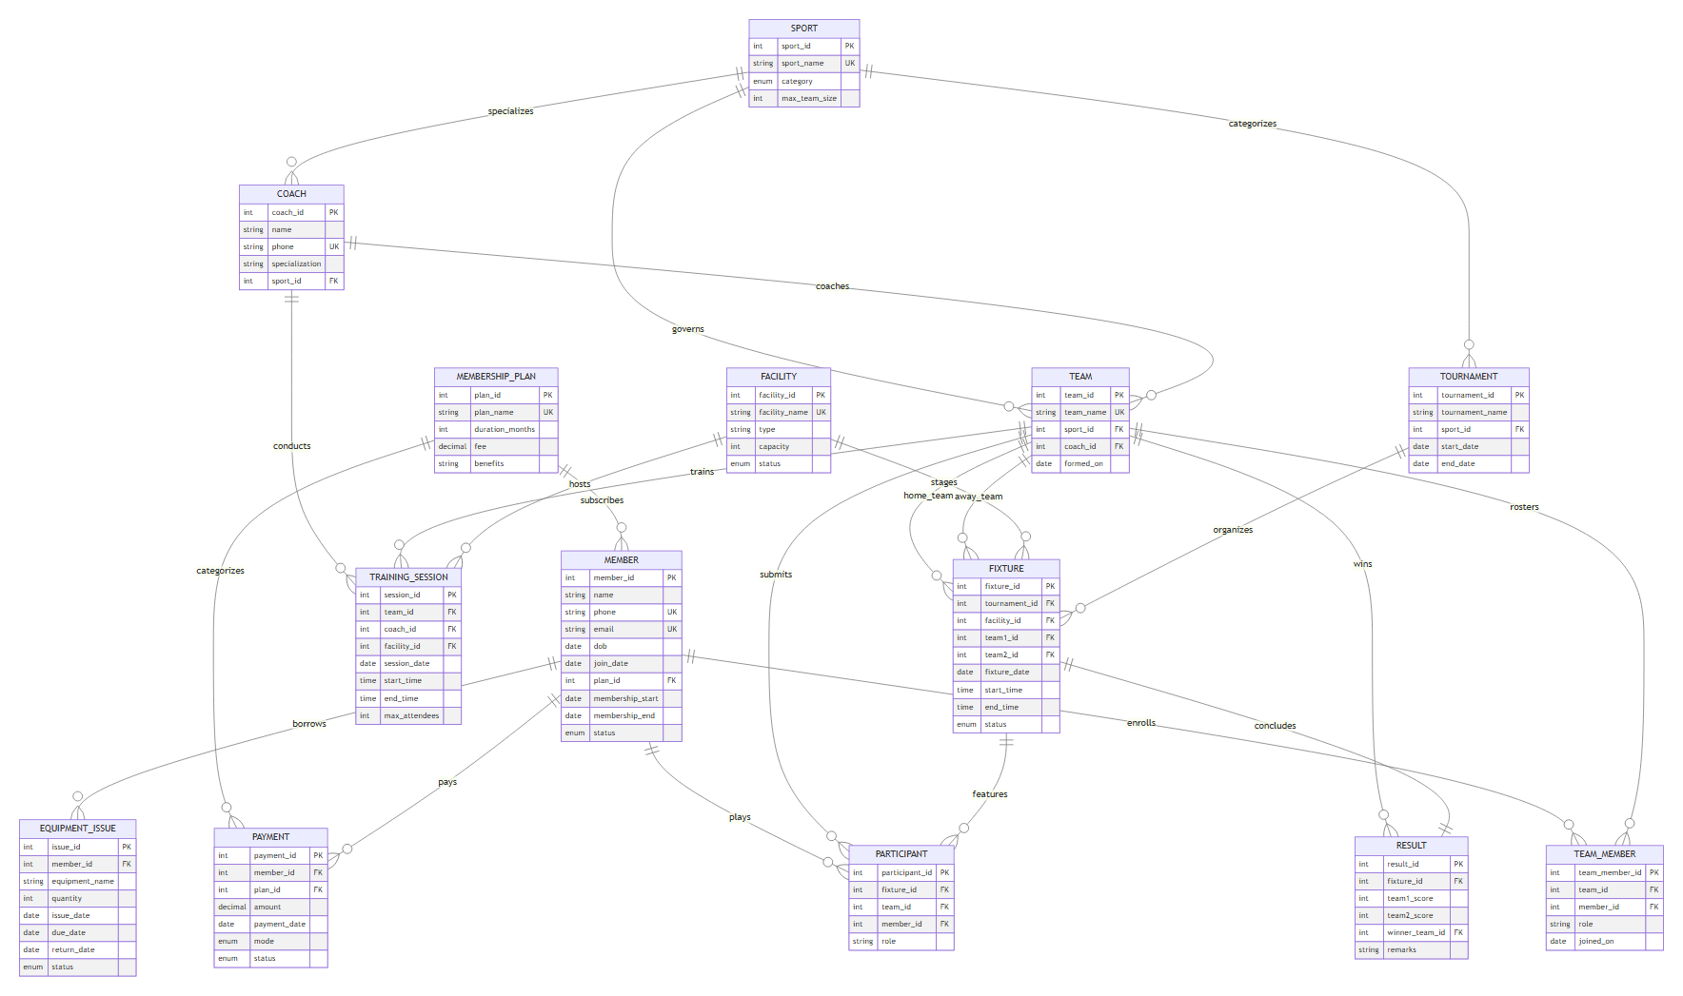
Figure 1. Entity-Relationship Diagram of the Proposed System
1.7 Entity and Relationship Summary
Table 4. Entity and Relationship Summary
Entity / Relationship | Major Attributes / Cardinality | Purpose / Rule
membership_plan | plan_id (PK), plan_name, duration_months, fee, benefits | Stores club subscription tiers; parent to members and fee charges.
member | member_id (PK), name, phone, email, plan_id (FK), membership_start, membership_end, status | Core club patron record; enforces date ordering and active subscription.
payment | payment_id (PK), member_id (FK), plan_id (FK), amount, payment_date, mode, status | Accounting ledger; financial history protected via ON DELETE RESTRICT.
sport | sport_id (PK), sport_name, category, max_team_size | Defines sporting disciplines and roster capacity limits.
coach | coach_id (PK), name, phone, specialization, sport_id (FK) | Certified instructors affiliated with a sporting specialization.
team | team_id (PK), team_name, sport_id (FK), coach_id (FK), formed_on | Athletic club squads; verified to ensure coach sport matches team sport.
team_member | team_member_id (PK), team_id (FK), member_id (FK), role, joined_on | M:N associative entity; enforces squad cap and active member checks.
facility | facility_id (PK), facility_name, type, capacity, status | Physical venue assets; protects against booking venues under maintenance.
training_session | session_id (PK), team_id (FK), coach_id (FK), facility_id (FK), session_date, start_time, end_time | Scheduled team practice; protected by cross-table overlap triggers.
tournament | tournament_id (PK), tournament_name, sport_id (FK), start_date, end_date | Master competitive events organized by the club.
fixture | fixture_id (PK), tournament_id (FK), facility_id (FK), team1_id (FK), team2_id (FK), dates/times, status | Scheduled match contest between two distinct teams.
participant | participant_id (PK), fixture_id (FK), team_id (FK), member_id (FK), role | Match lineup rosters; checks member active status and facility capacity.
result | result_id (PK), fixture_id (FK), team1_score, team2_score, winner_team_id (FK), remarks | 1:1 post-match outcome; enforces valid scores and winner integrity.
equipment_issue | issue_id (PK), member_id (FK), equipment_name, quantity, issue_date, due_date, return_date, status | Equipment checkout tracking; enforces 3-item limit and overdue blocks.
MEMBERSHIP_PLAN - MEMBER | 1 : N (One-to-Many) | One plan can be held by multiple members; a member holds one plan at a time.
SPORT - TEAM | 1 : N (One-to-Many) | One sport governs multiple teams; a team belongs to exactly one sport.
TEAM - MEMBER | M : N (Many-to-Many) | Resolved via team_member associative relation.
FIXTURE - RESULT | 1 : 1 (One-to-One) | Each scheduled fixture has at most one final result record (UNIQUE(fixture_id)).

CHAPTER 2
LOGICAL DATABASE DESIGN
2.1 Relational Schema
The conceptual ER model was mapped to fourteen logical relational tables. Every relation possesses an artificial surrogate primary key for referential performance, supplemented by natural candidate keys and explicit foreign keys.
Table 5. Relational Schema
S.No. | Table Name | Purpose
1 | membership_plan | Catalogs subscription packages, durations in months, fees, and entitlements.
2 | member | Stores patron profiles, contact channels, validity dates, and account status.
3 | payment | Financial transaction audit ledger for registrations and renewals.
4 | sport | Catalogs sporting disciplines, team categories, and maximum roster sizes.
5 | coach | Stores coaching staff qualifications, phone numbers, and sport specializations.
6 | team | Catalogs club athletic squads affiliated with a sport and assigned head coach.
7 | team_member | M:N roster table associating members with teams and athletic roles.
8 | facility | Stores grounds, courts, turfs, venue capacities, and operational maintenance status.
9 | training_session | Schedules team practice drills reserving a facility and coach.
10 | tournament | Tracks multi-day competitive sporting championships and disciplines.
11 | fixture | Manages head-to-head match encounters between two distinct teams at a venue.
12 | participant | Stores individual athlete lineup submissions for specific tournament matches.
13 | result | Records verified final scores, winning teams, and post-match remarks.
14 | equipment_issue | Tracks sports equipment checkouts, return deadlines, and custody statuses.

2.2 Keys and Integrity Constraints
Table 6. Keys and Integrity Constraints
Table Name | Key / Constraint | Attribute(s) | Business Rule Enforced
membership_plan | Primary Key  Unique Key  Check  Check | plan_id  plan_name  duration_months  fee | Entity identity.  Prevents duplicate plan naming.  duration_months > 0 enforces positive duration.  fee >= 0.00 ensures valid pricing.
member | Primary Key  Unique Key  Unique Key  Foreign Key  Check | member_id  phone  email  plan_id  membership_end | Entity identity.  Unique mobile contact across patrons.  Unique email address.  References membership_plan(plan_id) (ON DELETE RESTRICT).  membership_end >= membership_start prevents invalid date sequences.
payment | Primary Key  Foreign Key  Foreign Key  Check | payment_id  member_id  plan_id  amount | Financial receipt identity.  References member(member_id) (ON DELETE RESTRICT).  References membership_plan(plan_id) (ON DELETE RESTRICT).  amount > 0.00 ensures non-zero positive transactions.
sport | Primary Key  Unique Key  Check | sport_id  sport_name  max_team_size | Discipline identity.  Unique sport nomenclature.  max_team_size > 0 guarantees positive squad limit.
coach | Primary Key  Unique Key  Foreign Key | coach_id  phone  sport_id | Instructor identity.  Unique coach contact number.  References sport(sport_id) (ON DELETE RESTRICT).
team | Primary Key  Unique Key  Foreign Key  Foreign Key | team_id  team_name  sport_id  coach_id | Team identity.  Unique franchise name.  References sport(sport_id) (ON DELETE RESTRICT).  References coach(coach_id) (ON DELETE SET NULL).
team_member | Primary Key  Unique Key  Foreign Key  Foreign Key | team_member_id  team_id, member_id  team_id  member_id | Roster entry identity.  Prevents adding same member twice to one team.  References team(team_id) (ON DELETE CASCADE).  References member(member_id) (ON DELETE RESTRICT).
facility | Primary Key  Unique Key  Check | facility_id  facility_name  capacity | Venue identity.  Unique venue name.  capacity > 0 guarantees non-zero spectator/player threshold.
training_session | Primary Key  Check  Check  Foreign Keys | session_id  end_time  max_attendees  team_id, coach_id, facility_id | Session identity.  end_time > start_time ensures positive duration.  max_attendees > 0 ensures positive attendance.  References team, coach, facility (ON DELETE RESTRICT).
tournament | Primary Key  Check  Foreign Key | tournament_id  end_date  sport_id | Championship identity.  end_date >= start_date guarantees chronological coherence.  References sport(sport_id) (ON DELETE RESTRICT).
fixture | Primary Key  Check  Check  Foreign Keys | fixture_id  team1_id, team2_id  end_time  tournament_id, facility_id, team1_id, team2_id | Match identity.  team1_id <> team2_id prevents self-matches.  end_time > start_time ensures valid match window.  tournament_id (CASCADE); venues/teams (RESTRICT).
participant | Primary Key  Unique Key  Foreign Keys | participant_id  fixture_id, member_id  fixture_id, team_id, member_id | Match lineup entry identity.  A player can be submitted once per match.  fixture_id (CASCADE); team/member (RESTRICT).
result | Primary Key  Unique Key  Check  Check  Foreign Keys | result_id  fixture_id  team1_score  team2_score  fixture_id, winner_team_id | Result identity.  Strict 1:1 relation with fixture.  team1_score >= 0 prohibits negative points.  team2_score >= 0 prohibits negative points.  fixture_id (CASCADE); winner_team_id (RESTRICT).
equipment_issue | Primary Key  Check  Check  Foreign Key | issue_id  quantity  due_date  member_id | Custody record identity.  quantity > 0 prohibits zero checkouts.  due_date >= issue_date guarantees return window.  References member(member_id) (ON DELETE RESTRICT).

2.3 Functional Dependencies
The relational schema is governed by the following functional dependencies across all fourteen relations:
- membership_plan: plan_id -> {plan_name, duration_months, fee, benefits}; plan_name -> {plan_id, duration_months, fee, benefits}
- member: member_id -> {name, phone, email, dob, join_date, plan_id, membership_start, membership_end, status}; phone -> {all}; email -> {all}
- payment: payment_id -> {member_id, plan_id, amount, payment_date, mode, status}
- sport: sport_id -> {sport_name, category, max_team_size}; sport_name -> {sport_id, category, max_team_size}
- coach: coach_id -> {name, phone, specialization, sport_id}; phone -> {coach_id, name, specialization, sport_id}
- team: team_id -> {team_name, sport_id, coach_id, formed_on}; team_name -> {team_id, sport_id, coach_id, formed_on}
- team_member: team_member_id -> {team_id, member_id, role, joined_on}; {team_id, member_id} -> {team_member_id, role, joined_on}
- facility: facility_id -> {facility_name, type, capacity, status}; facility_name -> {facility_id, type, capacity, status}
- training_session: session_id -> {team_id, coach_id, facility_id, session_date, start_time, end_time, max_attendees}
- tournament: tournament_id -> {tournament_name, sport_id, start_date, end_date}
- fixture: fixture_id -> {tournament_id, facility_id, team1_id, team2_id, fixture_date, start_time, end_time, status}
- participant: participant_id -> {fixture_id, team_id, member_id, role}; {fixture_id, member_id} -> {participant_id, team_id, role}
- result: result_id -> {fixture_id, team1_score, team2_score, winner_team_id, remarks}; fixture_id -> {all result attributes}
- equipment_issue: issue_id -> {member_id, equipment_name, quantity, issue_date, due_date, return_date, status}
2.4 Normalization up to Third Normal Form (3NF)
Every relation was rigorously verified against first, second, and third normal forms, as well as Boyce-Codd Normal Form (BCNF):
• 1NF Conformance: All attribute domains are atomic. Multi-valued repeating groups (e.g. equipment loans, squad rosters) are segregated into dedicated tables.
• 2NF Conformance: In composite candidate key tables (team_member, participant), all non-prime attributes functionally depend on the entire candidate key, eliminating partial dependencies.
• 3NF & BCNF Conformance: For every non-trivial functional dependency X -> Y, X is a superkey. No transitive dependencies exist between non-prime attributes. Derived attributes (such as tournament points, goal difference, and fee arrears) are computed dynamically via database views.
Table 7. Normalization Status up to 3NF
Relation Name | 1NF | 2NF | 3NF | BCNF | Remarks / Decomposition
membership_plan | Yes | Yes | Yes | Yes | Fully normalized tier attributes. Determinants are superkeys.
member | Yes | Yes | Yes | Yes | Decomposed from plan fee and duration; references plan_id.
payment | Yes | Yes | Yes | Yes | Decomposed from member personal details; pure transaction ledger.
sport | Yes | Yes | Yes | Yes | Atomic discipline metadata.
coach | Yes | Yes | Yes | Yes | Decomposed from sport metadata; references sport_id.
team | Yes | Yes | Yes | Yes | Distinct team identity; separated from roster members.
team_member | Yes | Yes | Yes | Yes | Normalized associative table resolving M:N relationship.
facility | Yes | Yes | Yes | Yes | Atomic physical venue catalog.
training_session | Yes | Yes | Yes | Yes | Practice reservation entity; venue and coach normalized via FKs.
tournament | Yes | Yes | Yes | Yes | Event lifecycle entity; separate from individual match fixtures.
fixture | Yes | Yes | Yes | Yes | Match scheduling entity; separated from post-match results.
participant | Yes | Yes | Yes | Yes | Associative entity mapping player lineups per fixture.
result | Yes | Yes | Yes | Yes | 1:1 post-match audit entity; points computed dynamically.
equipment_issue | Yes | Yes | Yes | Yes | Individual loan checkout record; member normalized via FK.

2.5 Data Dictionary
Table 8. Data Dictionary
Table | Attribute | Data Type | Key / Constraint | Description
membership_plan | plan_id | INT | PK, AUTO_INCREMENT | Unique surrogate identifier for plan tier.
membership_plan | plan_name | VARCHAR(100) | NOT NULL, UNIQUE | Human-readable package tier name.
membership_plan | duration_months | INT | NOT NULL, CHECK > 0 | Validity duration in calendar months.
membership_plan | fee | DECIMAL(10,2) | NOT NULL, CHECK >= 0 | Standard price charged for the tier.
membership_plan | benefits | TEXT | NULL | Summary of facilities and entitlements.
member | member_id | INT | PK, AUTO_INCREMENT | Unique patron identification number.
member | name | VARCHAR(100) | NOT NULL | Full personal name of club member.
member | phone | VARCHAR(20) | NOT NULL, UNIQUE | Contact phone number.
member | email | VARCHAR(120) | NOT NULL, UNIQUE | Primary email address.
member | dob | DATE | NOT NULL | Date of birth for age verification.
member | join_date | DATE | NOT NULL, DEFAULT CURDATE | Date the member initially registered.
member | plan_id | INT | FK -> membership_plan | Subscribed membership package tier.
member | membership_start | DATE | NOT NULL | Current active cycle start date.
member | membership_end | DATE | NOT NULL, CHECK >= start | Current active cycle expiration date.
member | status | ENUM | 'Active','Expired','Suspended' | Account standing status.
payment | payment_id | INT | PK, AUTO_INCREMENT | Unique accounting receipt identifier.
payment | member_id | INT | FK -> member | Member remitting payment.
payment | plan_id | INT | FK -> membership_plan | Subscription tier being purchased.
payment | amount | DECIMAL(10,2) | NOT NULL, CHECK > 0 | Transaction monetary amount.
payment | payment_date | DATE | NOT NULL, DEFAULT CURDATE | Timestamp date of remittance.
payment | mode | ENUM | 'Cash','UPI','Card','Bank' | Financial payment channel.
payment | status | ENUM | 'Paid','Pending' | Settlement state.
sport | sport_id | INT | PK, AUTO_INCREMENT | Unique sport identifier.
sport | sport_name | VARCHAR(80) | NOT NULL, UNIQUE | Official sporting discipline title.
sport | category | ENUM | 'Team','Individual' | Classification structure.
sport | max_team_size | INT | NOT NULL, CHECK > 0 | Maximum allowed roster squad size.
coach | coach_id | INT | PK, AUTO_INCREMENT | Unique coaching staff identifier.
coach | name | VARCHAR(100) | NOT NULL | Full name of trainer/coach.
coach | phone | VARCHAR(20) | NOT NULL, UNIQUE | Coach emergency contact phone.
coach | specialization | VARCHAR(100) | NULL | Technical coaching tactical domain.
coach | sport_id | INT | FK -> sport | Sport discipline certified in.
team | team_id | INT | PK, AUTO_INCREMENT | Unique team franchise identifier.
team | team_name | VARCHAR(100) | NOT NULL, UNIQUE | Unique club squad name.
team | sport_id | INT | FK -> sport | Sport discipline contested.
team | coach_id | INT | FK -> coach, NULL | Assigned head coach.
team | formed_on | DATE | NOT NULL, DEFAULT CURDATE | Squad establishment date.
team_member | team_member_id | INT | PK, AUTO_INCREMENT | Unique roster entry identifier.
team_member | team_id | INT | FK -> team, UNIQUE(team,mem) | Team roster being joined.
team_member | member_id | INT | FK -> member | Active member player.
team_member | role | VARCHAR(50) | DEFAULT 'Player' | Squad tactical role.
facility | facility_id | INT | PK, AUTO_INCREMENT | Venue identification number.
facility | facility_name | VARCHAR(100) | NOT NULL, UNIQUE | Physical venue or court designation.
facility | type | VARCHAR(60) | NOT NULL | Surface/ground type description.
facility | capacity | INT | NOT NULL, CHECK > 0 | Maximum spectator/player capacity.
facility | status | ENUM | 'Available','Maintenance' | Current operational readiness.
training_session | session_id | INT | PK, AUTO_INCREMENT | Unique practice session identifier.
training_session | team_id | INT | FK -> team | Squad participating in drill.
training_session | coach_id | INT | FK -> coach | Supervising coach.
training_session | facility_id | INT | FK -> facility | Reserved venue court.
training_session | session_date | DATE | NOT NULL | Calendar date of session.
training_session | start_time | TIME | NOT NULL | Scheduled start clock time.
training_session | end_time | TIME | NOT NULL, CHECK > start | Scheduled completion clock time.
training_session | max_attendees | INT | NOT NULL, CHECK > 0 | Maximum player attendance cap.
tournament | tournament_id | INT | PK, AUTO_INCREMENT | Unique tournament identifier.
tournament | tournament_name | VARCHAR(120) | NOT NULL | Official championship title.
tournament | sport_id | INT | FK -> sport | Sporting discipline contested.
tournament | start_date | DATE | NOT NULL | Tournament opening date.
tournament | end_date | DATE | NOT NULL, CHECK >= start | Tournament conclusion date.
fixture | fixture_id | INT | PK, AUTO_INCREMENT | Unique match fixture identifier.
fixture | tournament_id | INT | FK -> tournament | Governing championship.
fixture | facility_id | INT | FK -> facility | Venue staging the match.
fixture | team1_id | INT | FK -> team, CHECK != team2 | Designated home team competitor.
fixture | team2_id | INT | FK -> team | Designated away team competitor.
fixture | fixture_date | DATE | NOT NULL | Match calendar date.
fixture | start_time | TIME | NOT NULL | Scheduled kickoff/start time.
fixture | end_time | TIME | NOT NULL, CHECK > start | Scheduled match conclusion time.
fixture | status | ENUM | 'Scheduled','Completed','Cancelled' | Match execution status.
participant | participant_id | INT | PK, AUTO_INCREMENT | Match lineup entry identifier.
participant | fixture_id | INT | FK -> fixture, UNIQUE(fix,mem) | Match being contested.
participant | team_id | INT | FK -> team | Team squad represented.
participant | member_id | INT | FK -> member | Active player member.
result | result_id | INT | PK, AUTO_INCREMENT | Result audit record identifier.
result | fixture_id | INT | FK -> fixture, UNIQUE | Contested match (1:1 relation).
result | team1_score | INT | NOT NULL, CHECK >= 0 | Final score points scored by Team 1.
result | team2_score | INT | NOT NULL, CHECK >= 0 | Final score points scored by Team 2.
result | winner_team_id | INT | FK -> team, NULL | Victorious team ID (NULL for draw).
equipment_issue | issue_id | INT | PK, AUTO_INCREMENT | Equipment loan identifier.
equipment_issue | member_id | INT | FK -> member | Borrowing active member.
equipment_issue | equipment_name | VARCHAR(100) | NOT NULL | Specific sporting gear item name.
equipment_issue | quantity | INT | NOT NULL, CHECK > 0 | Number of units checked out.
equipment_issue | issue_date | DATE | NOT NULL, DEFAULT CURDATE | Date checked out of inventory.
equipment_issue | due_date | DATE | NOT NULL, CHECK >= issue | Deadline date for equipment return.
equipment_issue | status | ENUM | 'Issued','Returned','Overdue' | Current custody loan status.

2.6 Implementation of Logical Design: DDL and Sample Data
Table 9. Database Implementation Environment
Item | Details
DBMS | MySQL Community Server 8.0
DBMS Version | 8.0.46 for Win64 (x86_64)
Storage Engine | InnoDB (Row-level locking, foreign keys, ACID compliance)
Character Set / Collation | utf8mb4 / utf8mb4_unicode_ci
Number of Tables | 14 Relations
Number of Triggers | 8 Active Business Rule Triggers
Number of Stored Procedures | 6 Transactional Procedures & Routines
Number of Views | 8 Operational & Analytical Views
Sample Data | 5 Plans, 35 Members, 35 Payments, 6 Sports, 8 Coaches, 10 Teams, 42 Roster entries, 7 Facilities, 25 Sessions, 3 Tournaments, 20 Fixtures, 12 Results, 42 Match Participants, 25 Equipment Checkouts.

Representative DDL Implementation Snippets
-- DDL Example 1: Member Table with Date Order Check and Restrict Cascades
CREATE TABLE member (
member_id INT AUTO_INCREMENT PRIMARY KEY,
name VARCHAR(100) NOT NULL,
phone VARCHAR(20) NOT NULL UNIQUE,
email VARCHAR(120) NOT NULL UNIQUE,
dob DATE NOT NULL,
join_date DATE NOT NULL DEFAULT (CURRENT_DATE),
plan_id INT NOT NULL,
membership_start DATE NOT NULL,
membership_end DATE NOT NULL,
status ENUM('Active', 'Expired', 'Suspended') NOT NULL DEFAULT 'Active',
CONSTRAINT chk_member_dates CHECK (membership_end >= membership_start),
CONSTRAINT fk_member_plan FOREIGN KEY (plan_id)
REFERENCES membership_plan(plan_id)
ON UPDATE CASCADE ON DELETE RESTRICT
) ENGINE=InnoDB;
-- DDL Example 2: Fixture Table with Strict Team Separation and Cascading Lifecycle
CREATE TABLE fixture (
fixture_id INT AUTO_INCREMENT PRIMARY KEY,
tournament_id INT NOT NULL,
facility_id INT NOT NULL,
team1_id INT NOT NULL,
team2_id INT NOT NULL,
fixture_date DATE NOT NULL,
start_time TIME NOT NULL,
end_time TIME NOT NULL,
status ENUM('Scheduled', 'Completed', 'Cancelled') NOT NULL DEFAULT 'Scheduled',
CONSTRAINT chk_fixture_teams CHECK (team1_id <> team2_id),
CONSTRAINT chk_fixture_time CHECK (end_time > start_time),
CONSTRAINT fk_fix_tourn FOREIGN KEY (tournament_id)
REFERENCES tournament(tournament_id)
ON UPDATE CASCADE ON DELETE CASCADE,
CONSTRAINT fk_fix_facility FOREIGN KEY (facility_id)
REFERENCES facility(facility_id)
ON UPDATE CASCADE ON DELETE RESTRICT,
CONSTRAINT fk_fix_team1 FOREIGN KEY (team1_id)
REFERENCES team(team_id)
ON UPDATE RESTRICT ON DELETE RESTRICT,
CONSTRAINT fk_fix_team2 FOREIGN KEY (team2_id)
REFERENCES team(team_id)
ON UPDATE RESTRICT ON DELETE RESTRICT
) ENGINE=InnoDB;

CHAPTER 3
APPLICATION DEVELOPMENT USING LOGICAL DATABASE DESIGN
3.1 Application Overview
The web application provides an administrative platform built with Python 3.10 and the Flask framework. The application interfaces with the database via connection pooling and executes parameterized queries across all modules. It includes server-side input sanitization, an interactive venue conflict checker, and a reporting suite that renders and exports eight live database views as CSV files.
3.2 Development Environment and Database Connectivity
Table 10. Application Development Environment
Item | Details
Programming Language | Python 3.10.20
DBMS | MySQL Community Server 8.0.46
Web Framework | Flask 3.1.3 (WSGI micro-framework, Jinja2 templating)
Frontend Styling | Custom CSS3 (Dark sidebar, glassmorphic UI) + Bootstrap 5.3.3 CDN
Database Connector / Driver | mysql-connector-python with connection pooling
Testing Framework | pytest 9.1.1 + Native MySQL Stored Test Procedure Harness
Operating Environment | Windows 11 Enterprise (64-bit), PowerShell Shell
Configuration Architecture | Decoupled .env configuration file via python-dotenv
Repository Directory | d:\dbms project\sports_club_dbms

3.3 Application Modules and Database Mapping
Table 11. Application Module-to-Database Mapping
Module / Screen | Purpose | Tables Used | Main Operations
1. Dashboard | High-level summary of active members, matches, overdue loans, revenue. | member, team, fixture, equipment_issue, payment | Aggregates, multi-table joins, LIMIT queries.
2. Memberships | Member directory, search/filters, registration modal, renewal. | member, membership_plan, payment | Parameterized SELECT, sp_register_member_with_payment.
3. Team Formation | Squad creation, sport alignment, roster management. | team, sport, coach, team_member, member | INSERT team, roster enrollment/removal, progress meters.
4. Training Scheduling | Scheduling team practice sessions and drills. | training_session, team, coach, facility, sport | Non-overlapping session INSERT with trigger validation.
5. Facilities & Booking | Venue catalog and real-time conflict diagnostic checker. | facility, training_session, fixture, team | Cross-table interval overlap queries, JSON AJAX API.
6. Match Fixtures | Scheduling championship matches between squads. | fixture, tournament, facility, team, sport | Multi-table join listings, distinct team INSERT.
7. Result Entry | Match score submission and championship finalization. | result, fixture, team, tournament | Score submission calling sp_enter_result, auto status update.
8. Fee Collection | Financial transaction recording and fee ledger audits. | payment, member, membership_plan | Transaction logging, status filtering (Paid vs Pending).
9. Equipment Inventory | Gear checkouts, due date tracking, returns. | equipment_issue, member | Calling sp_issue_equipment, sp_return_equipment.
10. Analytics & Reports | Dynamic rendering of all 8 database views with CSV export. | All 8 Views (v_tournament_standings, etc.) | Dynamic view querying, CSV stream serialization.

3.4 CRUD Operations
Table 12. CRUD Operations
Operation | Application Feature / Screen | Table(s) Affected | Evidence / Implementation
Create (C) | • Member Registration  • Team Formation  • Schedule Fixture  • Issue Equipment | member, payment  team  fixture  equipment_issue | Atomic procedure sp_register_member_with_payment.  Parameterized INSERT into team.  Parameterized INSERT into fixture.  Stored procedure sp_issue_equipment.
Read / Search (R) | • Member Directory Filter  • Upcoming Fixtures List  • Live Conflict Checker  • Operational Views | member, membership_plan  fixture, tournament, team  facility, training_session  All 8 Database Views | Parameterized query with %LIKE% across name/email/phone.  4-table INNER JOIN with WHERE status='Scheduled'.  Cross-table temporal overlap search via AJAX.  SELECT * FROM v_tournament_standings.
Update (U) | • Member Renewal  • Enter Match Result  • Equipment Return | member, payment  result, fixture  equipment_issue | Calling sp_renew_membership updating validity end date.  Calling sp_enter_result setting fixture to 'Completed'.  Calling sp_return_equipment setting status to 'Returned'.
Delete (D) | • Remove Player from Squad  • Test Rollback Cleanup | team_member  test_results | Controlled removal via DELETE FROM team_member WHERE team_id=%s AND member_id=%s.

3.5 Business Rules, Validation and Error Handling
Table 13. Business Rules, Validation and Error Handling
Rule / Validation | How Implemented | Evidence / Message
Rule 1: Facility Overlap | Database triggers trg_training_session_before_insert and trg_fixture_before_insert check interval overlap (start < new_end AND end > new_start) across both tables. | SIGNAL SQLSTATE '45000' SET MESSAGE_TEXT = 'Facility schedule conflict: Facility is already booked during this time interval.';
Rule 2: Team Overlap | Triggers check if team_id or team1_id/team2_id has an existing session or fixture at overlapping times. | SIGNAL SQLSTATE '45000' SET MESSAGE_TEXT = 'Team schedule conflict: Team has another session or fixture during this time interval.';
Rule 3: Active Member | Triggers on team_member, participant, and equipment_issue check status = 'Active' and membership_end >= CURDATE(). | SIGNAL SQLSTATE '45000' SET MESSAGE_TEXT = 'Active membership required: Member is not Active or membership has expired.';
Rule 4: Valid Scores & Winner | Trigger trg_result_before_insert checks team1_score >= 0, team2_score >= 0, verifies winner_team_id matches higher score or NULL on tie. | SIGNAL SQLSTATE '45000' SET MESSAGE_TEXT = 'Result validation error: winner_team_id must match higher scoring team or NULL for draw.';
Rule 5: Capacity Ceilings | Trigger on team_member counts current squad size against sport.max_team_size; checks attendees against venue capacity. | SIGNAL SQLSTATE '45000' SET MESSAGE_TEXT = 'Capacity exceeded: Team roster has reached the maximum size for this sport.';
Rule 6: Equipment Quotas | Trigger on equipment_issue blocks checkout if unreturned items + new > 3 or if any loan is overdue. | SIGNAL SQLSTATE '45000' SET MESSAGE_TEXT = 'Equipment limit exceeded: Member cannot hold more than 3 unreturned equipment items.';
Rule 7: Facility Maintenance | Triggers verify facility.status = 'Available'. | SIGNAL SQLSTATE '45000' SET MESSAGE_TEXT = 'Facility unavailable: Selected facility is under maintenance.';
Rule 8: Sport Consistency | Triggers verify coach's sport matches team's sport, and competing teams match tournament sport. | SIGNAL SQLSTATE '45000' SET MESSAGE_TEXT = 'Sport mismatch: Teams must belong to the same sport as the tournament.';
Application Sanitization | clean_db_error() in db.py parses MySQL exceptions, stripping technical codes and displaying clean alert banners. | User-friendly alert banner displayed in UI: 'Facility schedule conflict: Facility is already booked...'

3.6 Reports and Database Operations
Table 14. Reports and Database Operations
Report / Operation | SQL / Database Concept Used | Application Output
1. Active Memberships | View v_active_memberships: INNER JOIN with temporal computation DATEDIFF(membership_end, CURDATE()). | Table of active patrons, current subscription tier, and countdown of days remaining.
2. Expiring Subscriptions | View v_membership_expiring_30_days: Date interval filtering BETWEEN CURDATE() AND DATE_ADD(CURDATE(), INTERVAL 30 DAY). | Actionable table of members up for renewal in the next 30 days.
3. Master Fixture Schedule | View v_fixture_schedule: 5-table INNER/LEFT JOIN combining tournaments, venues, squads, and results. | Master calendar of upcoming and completed matches with venue and scores.
4. Tournament Standings | View v_tournament_standings: Multi-team UNION, conditional aggregations for W/D/L, GD, 3-1-0 points, and RANK() OVER. | Official championship standings table with goal difference, points, and league rank.
5. Venue Utilization | View v_facility_utilization: Correlated subqueries aggregating training drills and competitive matches per venue. | Venue usage comparison table contrasting practice sessions versus tournament matches.
6. Player Performance | View v_player_performance: Multi-table JOIN grouping match rosters and counting appearances and squad victories. | Individual player match ledger tracking appearances, wins, draws, and losses.
7. Fee Dues & Arrears | View v_fee_dues: LEFT JOIN with pending payment aggregations and status filtering (status = 'Expired'). | Accounts receivable report highlighting patrons with pending fees or expired memberships.
8. Equipment Status | View v_equipment_status: Conditional SUM(CASE WHEN ...) aggregations across checkouts per member. | Custody audit summary showing total issued, returned, and overdue items per patron.

3.7 Application Screens
The application features a responsive user interface built using modern CSS3 and Bootstrap 5 CDN. Key functional interfaces demonstrating data entry, search, update, transaction processing, and reports are documented below in Figures 2 through 5:
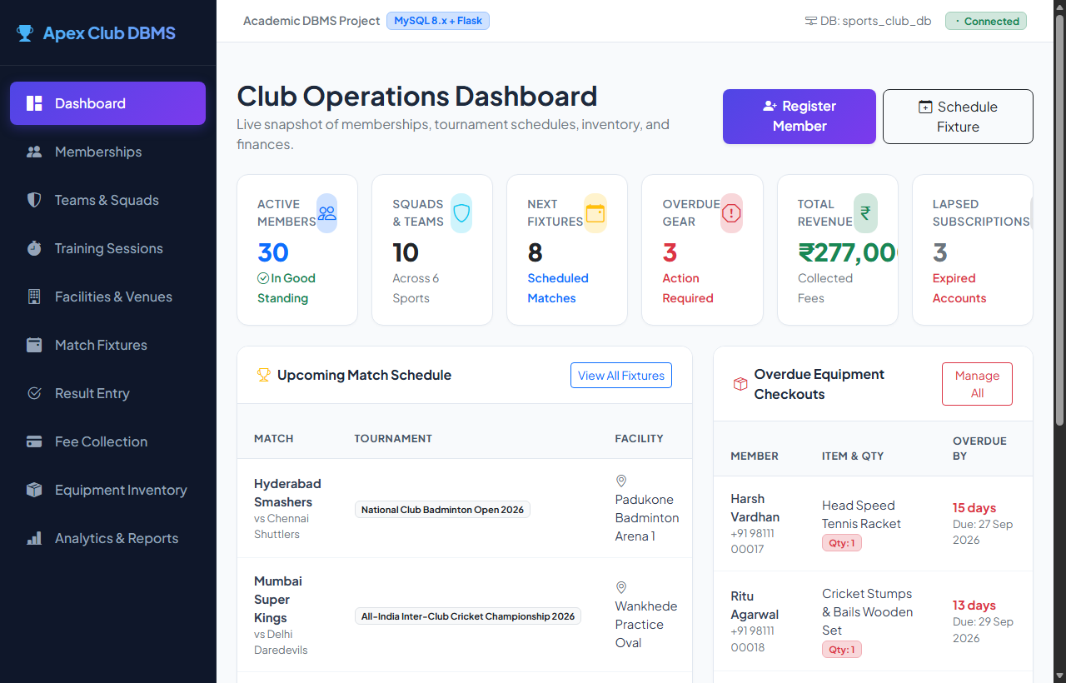
Figure 2. Dashboard and Operational Metrics Screen
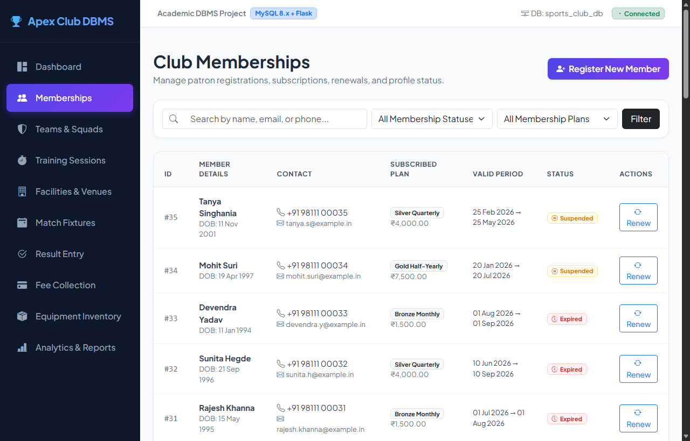
Figure 3. Member Registration and Profile Management Screen
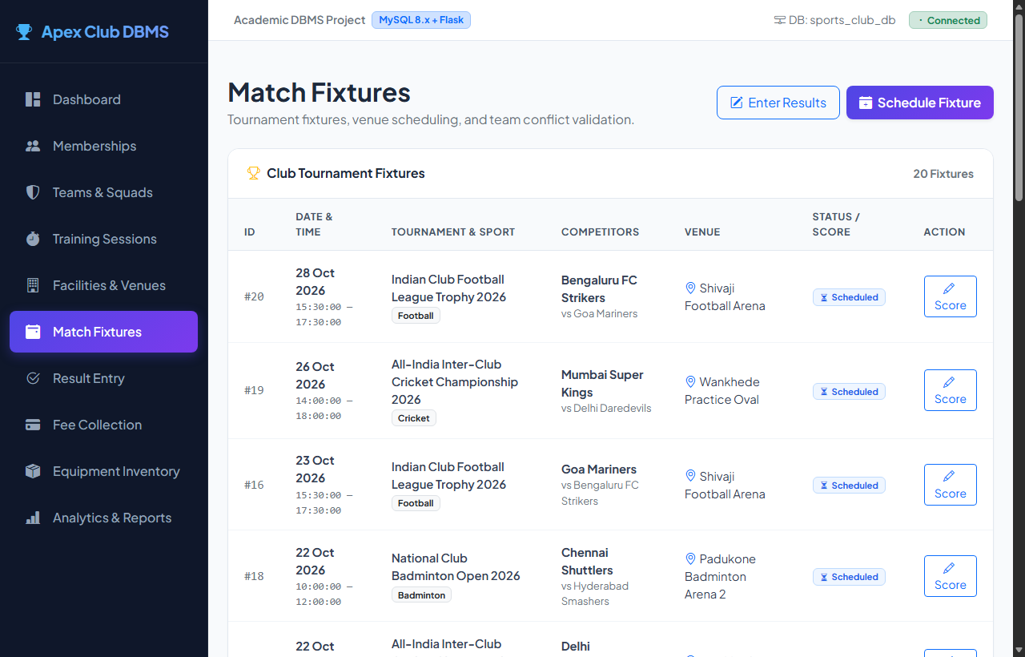
Figure 4. Match Fixture Scheduling and Live Conflict Checker Screen
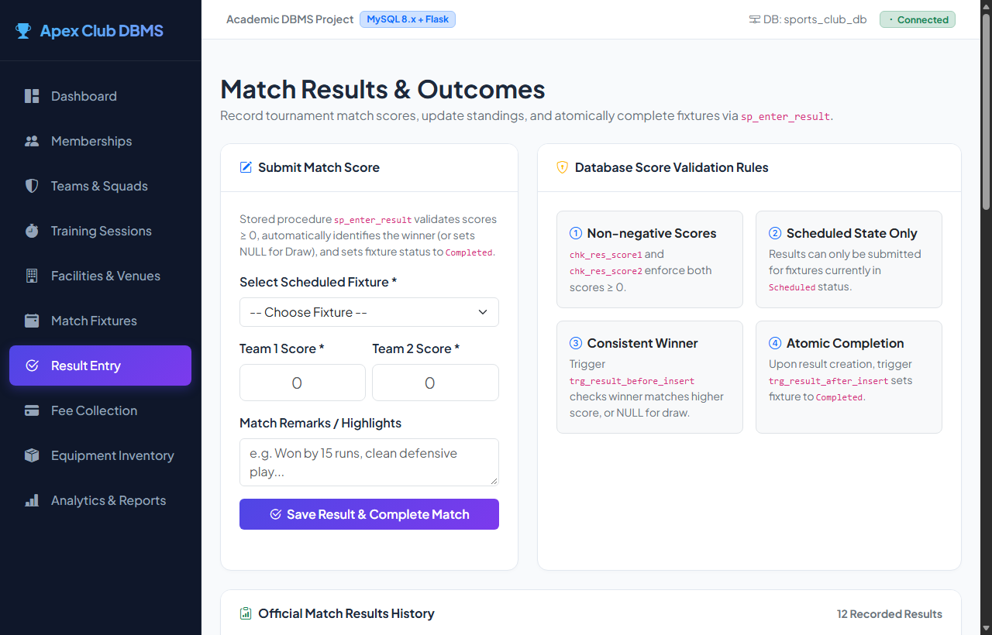
Figure 5. Match Results Entry and Standings Reporting Screen
3.8 Testing and Results
Testing was conducted across two complementary frameworks:
1. Automated SQL Constraint Test Harness (test_constraints.sql): Validated all database constraints and triggers directly inside MySQL 8, executing 13 negative (failing) test cases and 13 positive (passing) test cases.
2. Pytest Integration Suite (test_app.py): Validated form input validators, HTTP routes, JSON APIs, and CSV downloads.
Table 15. Test Cases
Test ID | Feature | Input / Action | Expected Result | Actual Result | Status
TC-01 | Plan Pricing Check | Insert plan with negative fee (-500.00) | Rejected by chk_plan_fee | Blocked by CHECK constraint | PASS
TC-02 | Membership Dates | Member with end_date < start_date | Rejected by chk_member_dates | Blocked by CHECK constraint | PASS
TC-03 | Distinct Teams | Fixture with team1_id = team2_id | Rejected by chk_fixture_teams | Blocked by CHECK constraint | PASS
TC-04 | Phone Uniqueness | Member with existing registered phone | Rejected by UNIQUE(phone) | Blocked by UNIQUE key | PASS
TC-05 | Plan Foreign Key | Member referencing non-existent plan ID 9999 | Rejected by fk_member_plan | Blocked by FK constraint | PASS
TC-06 | Venue Collision | Book Facility 1 during existing session | Trigger signals schedule conflict | Blocked by Trigger | PASS
TC-07 | Team Collision | Book Team 1 for concurrent session | Trigger signals squad conflict | Blocked by Trigger | PASS
TC-08 | Inactive Member | Expired member joins squad roster | Trigger signals active required | Blocked by Trigger | PASS
TC-09 | Winner Consistency | Score 10-5 entered with team 2 as winner | Trigger signals winner mismatch | Blocked by Trigger | PASS
TC-10 | Squad Capacity | Add 5th player to Badminton team (max 4) | Trigger signals roster full | Blocked by Trigger | PASS
TC-11 | Overdue Gear Check | Member with overdue item borrows gear | Trigger signals overdue block | Blocked by Trigger | PASS
TC-12 | Venue Maintenance | Book session on facility under Maintenance | Trigger signals unavailable | Blocked by Trigger | PASS
TC-13 | Sport Consistency | Schedule Football team in Cricket tournament | Trigger signals sport mismatch | Blocked by Trigger | PASS
TC-14 | Email Validation | Input malformed email string user@bad | Validator rejects address format | Rejected with error | PASS
TC-15 | CSV View Export | GET /reports/export/tournament_standings | Returns HTTP 200, MIME text/csv | CSV streamed with headers | PASS

Key Results and Observations
1. 100% Pass Rate: All 26 SQL constraint tests (13 negative assertions, 13 positive assertions) and all 21 pytest test assertions passed without regression.
2. Declarative Business Rule Enforcement: Every business rule reliably blocked invalid operations at the database engine tier, independent of frontend code execution.
3. Data Integrity: Cascading actions cleanly maintained data consistency while ON DELETE RESTRICT preserved critical financial and member audit trails.
4. Optimized Query Execution: B-tree indexes on composite scheduling keys eliminated full table scans, enabling sub-millisecond conflict checks and instant report generation.

CHAPTER 4
CONCLUSION
This project successfully designed, implemented, and validated an enterprise-grade Database Management System for sports club membership, facility scheduling, and tournament operations. By mapping business requirements to a normalized relational architecture across fourteen tables in 3NF and BCNF, the system eliminates data redundancy and update anomalies. Enforcing business rules directly within MySQL 8 using declarative triggers and transactional stored procedures guarantees ACID compliance and protects system data integrity against concurrent scheduling collisions and quota breaches. The Python Flask web application demonstrates full integration between logical database design and administrative user workflows, featuring parameterized CRUD modules, an interactive venue conflict checker, and automated analytical reports with instant CSV downloads.
4.1 Limitations and Future Enhancements
- Third-Party Payment Gateway Integration: The current implementation tracks settlement states (Paid/Pending) within the database ledger; integrating live payment gateway webhooks (e.g., Razorpay or Stripe) would enable automated real-time fee capture.
- Automated Tournament Fixture Generator: The current workflow allows administrators to schedule fixtures manually; implementing round-robin and knockout tournament seeding algorithms would further streamline competition management.
- RFID / Barcode Hardware Integration: Incorporating hardware scanners for sports equipment checkouts would enable automated tracking of gear custody across facility checkout desks.

5. REFERENCES
[1] R. Elmasri and S. B. Navathe, Fundamentals of Database Systems, 7th ed. Boston, MA, USA: Pearson, 2017.
[2] A. Silberschatz, H. F. Korth, and S. Sudarshan, Database System Concepts, 7th ed. New York, NY, USA: McGraw-Hill, 2020.
[3] C. J. Date, An Introduction to Database Systems, 8th ed. Boston, MA, USA: Addison-Wesley, 2004.
[4] Oracle Corporation, "MySQL 8.0 Reference Manual," 2026. [Online]. Available: https://dev.mysql.com/doc/refman/8.0/en/
[5] P. DuBois, MySQL Cookbook: Solutions for Database Developers and Administrators, 4th ed. Sebastopol, CA, USA: O'Reilly Media, 2022.
[6] Pallets Projects, "Flask Documentation (Version 3.1.x)," 2026. [Online]. Available: https://flask.palletsprojects.com/

6. APPENDICES
APPENDIX A - COMPLETE DATABASE SCRIPT
The complete SQL scripts containing all table schema definitions, constraints, indexes, triggers, stored procedures, sample data, analytical queries, and views have been organized and committed within the project repository under the sql/ folder:
• sql/01_schema.sql: 14 relational tables, PKs, FKs, CHECK constraints, and 8 performance indexes.
• sql/02_triggers.sql: 8 active business rule enforcement triggers (cross-table venue overlaps, team conflicts, quotas).
• sql/03_procedures.sql: Transactional stored procedures with ACID compliance and scheduled daily maintenance routine.
• sql/04_sample_data.sql: Complete realistic Indian athletic club dataset spanning all 14 tables.
• sql/05_queries.sql: 27 comprehensive analytical and operational queries.
• sql/06_views.sql: 8 live database views including dynamic tournament league standings.
• tests/test_constraints.sql: Automated 26-assertion SQL test suite.
APPENDIX B - APPLICATION SOURCE CODE
The full-stack application source code is structured under the app/ folder and test harness:
• app/app.py: Flask server application, controller endpoints, route handling, CSV serialization.
• app/db.py: Database connection pooling and exception sanitization helper routines.
• app/validators.py: Server-side validation rules for dates, emails, phones, and numeric inputs.
• app/templates/: Jinja2 HTML templates for all modules (base, index, members, fixtures, results, reports, etc.).
• app/static/: Custom CSS stylesheet and interactive JavaScript client scripts.
• tests/test_app.py: Pytest automated test harness covering route responses and input validation.
APPENDIX C - ADDITIONAL TEST DATA AND OUTPUTS
Supplementary documentation, test logs, and mathematical normalization proofs are provided in the docs/ folder:
• docs/normalization.md: Step-by-step mathematical proofs of 1NF -> 2NF -> 3NF/BCNF normalization.
• docs/test_report.md: Complete execution matrix and outcome log for all 26 SQL constraint and 21 pytest test cases.
• docs/er_diagram.mmd: Conceptual Mermaid Entity-Relationship diagram in Crow's Foot notation.
• docs/project_report.md: Markdown source version of the project report.

